

Taken By

 Jim

 Greg

 Jeannie

**Fact Finder**

Confidential Questionnaire for:

______________________________________

Date: ___________________



**All Mark Insurance Services**

**25801 Obrero Dr. #11, Mission Viejo, CA 92691**

**P: (800) 570-8395 F: (949) 830-3340**

K:\New Client Material\Factfinders \Factfinder

Page 1



**Opening Questions**

1. How did you hear about us and what do you know about our company?
2. What are you currently doing in preparation for your financial future?
3. What do you like most about what you are doing?
4. What don’t you like about your current financial situation?
5. What would you like to see enhanced or improved?
6. Describe the ideal financial professional/financial strategy?
7. What has been your past experience with preparing for your financial future?
8. What would you “ideally” like to accomplish with your financial strategy?
9. Tell me about your decision making process?
10. What keeps you up at night?

Page 2

***DEMOGRAPHIC & INCOME PROFILE***

|  |  |  |  |  |  |
| --- | --- | --- | --- | --- | --- |
| **CLIENT’S INFORMATION:** | | | **SPOUSE’S INFORMATION:** | | |
| **Name:** | | | **Name:** | | |
| Address: | | | City/St/Zip: | | |
| Home Phone: | | | **Wedding Anniv Date:** | | |
| Cell Phone Number: | | | Cell Phone Number: | | |
| Work Phone Number: | | | Work Phone Number: | | |
| E-Mail: | | | E-Mail: | | |
| DOB: | Age: | Smoker?: Y N | DOB: | Age: | Smoker?: Y N |

|  |  |  |  |
| --- | --- | --- | --- |
| **INCOME** | | | |
| **CLIENT SPOUSE** | | | |
| Retirement Age: Years Employed: | | Retirement Age: Years Employed: | |
| Employer: | | Employer: | |
| Occupation: | | Occupation: | |
| Wages Income: $ Bonus Income: $ | | Wages Income: $ Bonus Income: $ | |
| Rental Income: $ SS Income: $ | | Rental Income: $ SS Income: $ | |
| Annuity Income: $ Alimony Income: $ | | Annuity Income: $ Alimony Income: $ | |
| Other Income: $ Source of “Other Income”: | | Other Income: $ Source of “Other Income”: | |
| Monthly Net Income: $ | | Monthly Net Income: $ | |
| **Combined Gross Income: $** | | **Combined Taxable Income**: $ | |
| Total Monthly Living Expenses: $ | | Deductions: $ | |
| Current St/Fed Marginal Tax Bracket: | State: % | Federal: % | Combined Total: % |
| **Combined Monthly Net Income: $ Est. Monthly Expenses: $ Discretionary Cash: $** | | | |

|  |  |
| --- | --- |
| **CLIENT’S PENSION INFORMATION SPOUSE’S PENSION INFORMATION** | |
| Do you have a Pension? Yes No | Do you have a Pension? Yes No |
| COLA? Yes No %: | COLA? Yes No %: |
| Balance: $ | Balance: $ |
| Amount at Retirement: $ | Amount at Retirement: $ |
| Does it continue after your death? Yes No | Does it continue after their death? Yes No |
| % to beneficiary after your death? | % to beneficiary after their death? |

Page 3

|  |  |  |  |
| --- | --- | --- | --- |
| **Family Information** | | | |
| **Children / Dependents (or other information):** | | | |
| Child #1 Name: |  | | DOB: |
| Child #2 Name: |  | | DOB: |
| Child #3 Name: |  | | DOB: |
| Child #4 Name: |  | | DOB: |
| Child #5 Name: |  | | DOB: |
| Child #6 Name: |  | | DOB: |
| **Client’s Parent Information** | | **Spouse’s Parent Information** | |
| Father’s Information: | | Father’s Information: | |
| _____Alive General Health: _____________________  _____Deceased If deceased, at what age?_________ | | _____Alive General Health: _____________________  _____Deceased If deceased, at what age?_________ | |
| Mother’s Information: | | Mother’s Information: | |
| _____Alive General Health: _____________________  _____Deceased If deceased, at what age?_________ | | _____Alive General Health: _____________________  _____Deceased If deceased, at what age?_________ | |
| Do your parents own a home? Yes No | | Do your parents own a home? Yes No | |
| Value of their home $ Balance $ | | Value of their home $ Balance $ | |
| Do they have a trust? Yes No | | Do they have a trust? Yes No | |
| How many siblings do you have? | | How many siblings do you have? | |

|  |  |
| --- | --- |
| **HEALTH INSURANCE INFORMATION** | |
| **CLIENT** | **SPOUSE** |
| Do you have LTC Ins? Yes No | Do they have LTC Ins? Yes No |
| Do you have disability Ins? Yes No | Do they have disability Ins? Yes No |
| Do you have Health Ins? Yes No  If yes, what type? | Do they have Health Ins? Yes No  If yes, what type? |
| Monthly Premium: $ | Monthly Premium: $ |

|  |  |  |  |  |  |  |  |
| --- | --- | --- | --- | --- | --- | --- | --- |
| **LIFE INSURANCE INFORMATION** | | | | | | | |
|  | Husband / Wife | TYPE* | Company | Face Amount | Annual Premium | Cash Value | Year |
| 1 | C / S |  |  | $ | $ | $ |  |
| 2 | C / S |  |  | $ | $ | $ |  |
| 3 | C / S |  |  | $ | $ | $ |  |
| 4 | C / S |  |  | $ | $ | $ |  |

* Types:Whole, Term, Universal, Indexed Universal, Variable Universal Page 4

|  |  |  |  |
| --- | --- | --- | --- |
| **PROPERTY DETAILS:** | | | |
|  | **Primary Residence:** | **Other Property:** | **Other Property:** |
| Fair Market Value: | $ | $ | $ |
| Original Purchase Price: | $ | $ | $ |
| Verifiable Cost of Improvements: | $ | $ | $ |
| Total Mortgage Payments: | $ | $ | $ |
| Total Rental Income: | $ | $ | $ |
| **CURRENT MORTGAGE DETAILS:** | | | |
| Beginning Date: | / / | / / | / / |
| Term: | Years | Years | Years |
| Type (circle one): | Amortized / Int. Only / Neg Am | Amortized / Int. Only / Neg Am | Amortized / Int. Only / Neg Am |
| Amount: | $ | $ | $ |
| Interest Rate: | % | % | % |
| Payment, P&I: | $ | $ | $ |
| Remaining Balance: | $ | $ | $ |
| Tax & Insurance: | $ | $ | $ |
| **SECOND MORTGAGE DETAILS:** | | | |
| Beginning Date: | / / | / / | / / |
| Term: | Years | Years | Years |
| Type (circle one): | Amortized / Int. Only / Neg Am | Amortized / Int. Only / Neg Am | Amortized / Int. Only / Neg Am |
| Amount: | $ | $ | $ |
| Interest Rate: | % | % | % |
| Payment, P&I: | $ | $ | $ |
| Remaining Balance: | $ | $ | $ |
| Tax & Insurance: | $ | $ | $ |
| **EQUITY LINE:** | | | |
| % Loan to Value (LTV) | % | % | % |
| Term: | Years | Years | Years |
| Type (circle one): | Amortized / Int. Only / Neg Am | Amortized / Int. Only / Neg Am | Amortized / Int. Only / Neg Am |
| Amount: | $ | $ | $ |
| Interest Rate: | % | % | % |
| Payment, P&I: | $ | $ | $ |

How much per month have you been paying into extra Principal payments? $ __________________ Repositionable? Y / N

Page 5

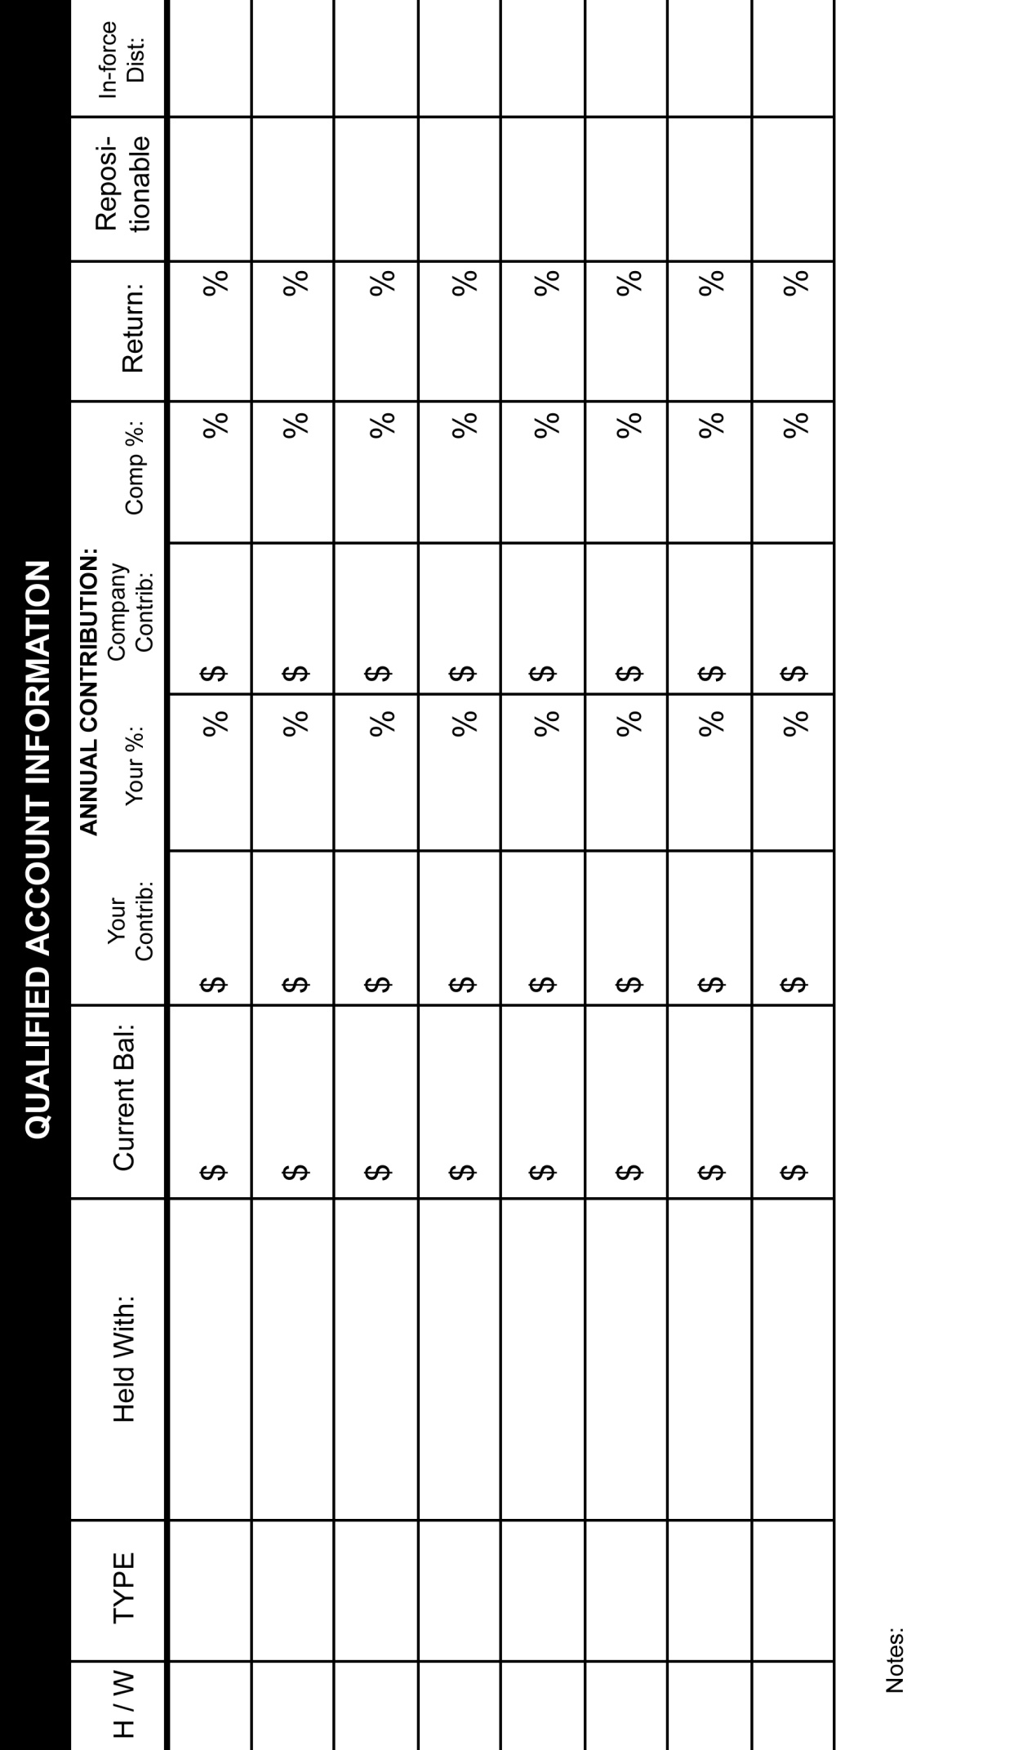

* Qualified Accounts are tax deferred funds and include: IRAs, Roth IRAs, 401K, 457, 403B, Defined Benefit, etc.

Page 6

|  |  |  |  |  |  |
| --- | --- | --- | --- | --- | --- |
| ***Non-Qualified Accounts \**** | | | | | |
| TYPE | Where Held | Current Balance | Annual Contribution | Return | Repositionable |
| Checking |  | $ | $ | % | Y / N |
| Savings |  | $ | $ | % | Y / N |
| CDs |  | $ | $ | % | Y / N |
| Brokerage |  | $ | $ | % | Y / N |
| Roth |  | $ | $ | % | Y / N |
| Annuities |  | $ | $ | % | Y / N |
|  |  | $ | $ | % | Y / N |
|  |  | $ | $ | % | Y / N |
|  |  | $ | $ | % | Y / N |
|  |  | $ | $ | % | Y / N |
| * Non-Qualified Accounts include: Savings Accounts, Checking Accounts, College Savings Account s, Brokerage Accounts,  CDs, Stocks and Bonds, Mutual Funds, etc. | | | | | |

|  |  |  |  |  |  |  |
| --- | --- | --- | --- | --- | --- | --- |
| **CURRENT LIABILITIES \*** | | | | | | |
|  | TYPE | Balance Remaining | Monthly Payments  Regular / Minimum | Payments Remaining | Interest Rate | Pay off & reposition monthly payments? |
| 1 |  | $ | $ / |  | % | Y / N |
| 2 |  | $ | $ / |  | % | Y / N |
| 3 |  | $ | $ / |  | % | Y / N |
| 4 |  | $ | $ / |  | % | Y / N |
| 5 |  | $ | $ / |  | % | Y / N |
| 6 |  | $ | $ / |  | % | Y / N |
| 7 |  | $ | $ / |  | % | Y / N |

* Liabilities include: credit card payments, loans and/or car payments, utilities, mortgage and/or rental payments, etc

1. Do you see incurring other financial obligations in the next 1-5 years (circle all that apply)?

New Car Estate Planning/Trust College expense Home Remodeling

Wedding Change in employment Retirement Reverse Mortgage

Other ___________________________________

Page 7

***DEMOGRAPHIC & INCOME PROFILE***

1. What is your financial philosophy (circle one)? Conservative Moderate Aggressive

2. What is the most important consideration in your financial planning (rank from 1 to 8, with 1 being the most important)?

____ Preservation of Capital ____ Increasing current cash income

____ Aggressive investment growth ____ Reducing current income taxes

____ Planning IRA distributions ____ Estate planning

____ Planning for college tuition ____ Passing assets to heirs

3. How long do you plan on living (please circle one for each spouse) H: 50’s – 60’s 70’s 80’s 90’s 100’s

W: 50’s – 60’s 70’s 80’s 90’s 100’s

4. Is it your desire to (circle one)

Remain in your current home

Move to a retirement community

Move to another home (Are you familiar with a reverse mortgage?)

5. Have you established a Living Trust to protect your family’s assets and avoid probate? Yes No

If yes, is your trust information up to date? Yes No

If yes, are all of your beneficiary forms current? Yes No

If yes, type of trust (circle): Revocable Irrevocable ILIT IRA Other ___________________

If yes, date when it was last reviewed: ___________________

If no, are you interested in learning more about the benefits of a Living Trust? Yes No

***INCOME & ASSET PROFILE***

1. Do you prepare your own tax returns? Yes No

2. Did you receive a tax refund last year? Yes No

3. On average, what has your refund been over the past few years? $_______________

4. Do you gift money annually to family? Yes No

If yes, is this part of your estate planning? Yes No

5. If you gift, how much do you contribute annually? $_______________

Page 8

***CURRENT RETIREMENT PROFILE***

1. Do you participate in your employer’s retirement plan? H: Yes No W: Yes No

2. Are you self-employed? H: Yes No W: Yes No

3. If self employed, are you: Sole Proprietor Partnership C-Corp S-Corp Other _____________

4. At what age do you plan to retire? H: ______ W: ______

5. What is your current health status (please circle one for each spouse): H: Good Fair Poor

W: Good Fair Poor

***MISC***

1. How much can you set aside on a regular basis to meet your objectives? $ __________________ Repositionable? Y / N

2. Date attended Missed Fortune Seminar: ______/______/______

3. Date attended Clarity Retreat: ______/______/______

4. Read Missed Fortune or Missed Fortune 101? Yes No

5. We often give ‘Thank You’ gifts to our clients. Is an alcoholic gift such as a bottle of wine OK with you? Yes No

|  |
| --- |
| Accountant Name: |
| Address: |
| City: State: ZIP: |
| Phone: FAX: E-Mail: |
|  |
| Lawyer Name: |
| Address: |
| City: State: ZIP: |
| Phone: FAX: E-Mail: |

Page 9



**What Keeps You Up At Night?**

Name:_________________________________________________ Date:_________

**RETIREMENT**

 Financial issues as retirement draws near

 Do I have enough to retire?

 How long will my money last?

 Should I roll over my 401(k)?

 Which is best? Ordinary or Roth?

 Should I consolidate my retirement plans?

 What are my 401(k) distribution options?

 Required Minimum Distributions (RMDs)

 Which asset to spend 1st, keep to last?

**ESTATE PLANNING**

 Are my beneficiary designations correct?

 Should I stretch my IRA?

 Have I told my survivors my wishes?

 Do I know what I need to know about

estate and inheritance taxes?

 Is my current plan maximizing my tax

deductions to my heirs?

 Should I set up a trust?

 What should I do with my home at my death?

 What is IRD?

 Am I effectively managing my estate?

 How can I give money away, have enough

retirement income, and still pass my assets

to my children/grandchildren?

 How do I spend the assets I have left efficiently?

**FINANCIAL BASICS**

 Organizing my financial records

 Create a household budget

 Reducing debt

 Creating a simplified “big picture” plan

**EDUCATION PLANNING**

 What will it cost me to get ready?

 Understanding college savings options

 529 college planning

 Do I qualify for financial aid for my kids?

 What is FAFSA?

 State or Private schools?

 Is there a way to shelter assets?

**LIFE EVENTS / FAMILY SECURITY**

 Upcoming wedding expenses

 What to do when a relative dies

 New job/career – benefits review

 401(k) plan choices for job changes

 Life Insurance – How much is enough?

 Divorce/Spouse death: Now you’re “on

your own”

 Grandchildren have arrived! I want to

enhance their financial future

 Disability: Who will pay my monthly bills

when I can’t work?

**ELDER CARE**

 Caring for my aging parents

 How will I be able to help a loved one

with Alzheimer’s disease?

 Being a caregiver

 Finding the right care facility for an older

relative

 Choosing long-term care insurance

 When do I consider a Nursing Home?

 Making sense of Medicare

 Power of Attorney issues

 Executor and Executrix responsibilities

Page 10